**DAA Lab 3**

Name: Sarakshi Mamodia

Reg No: 231071056

**Aim**: To find the net and gross salary of the employees and find the minimum and maximum salary. **Algorithm:**

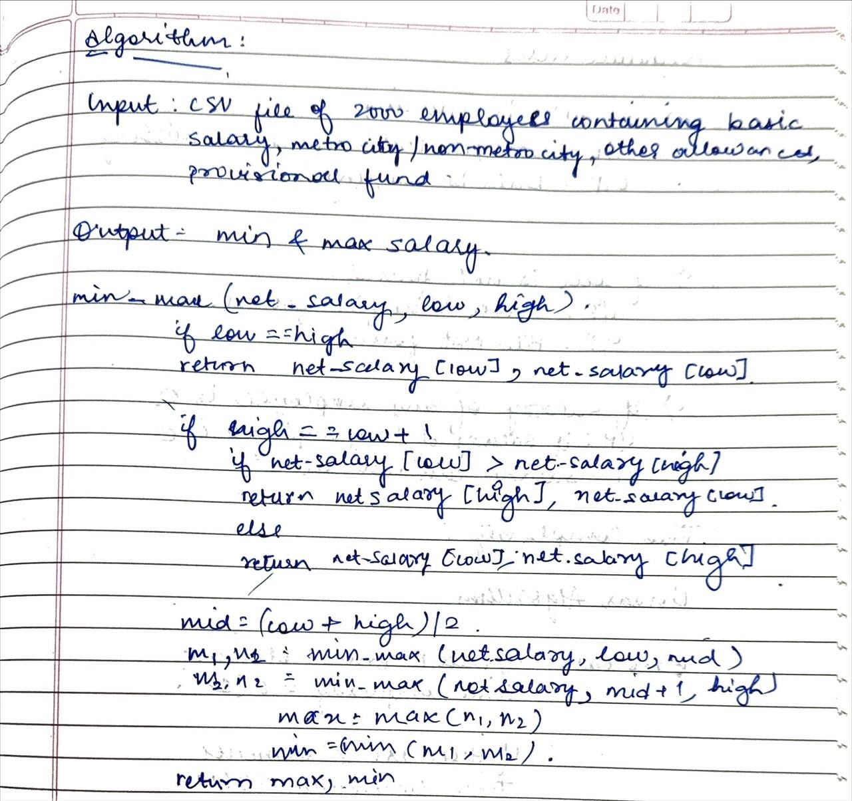

**Test Cases:**

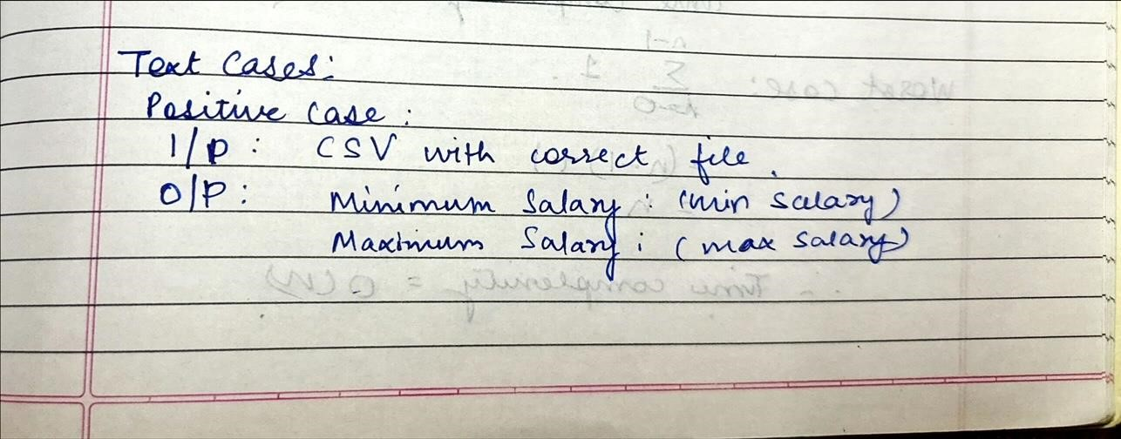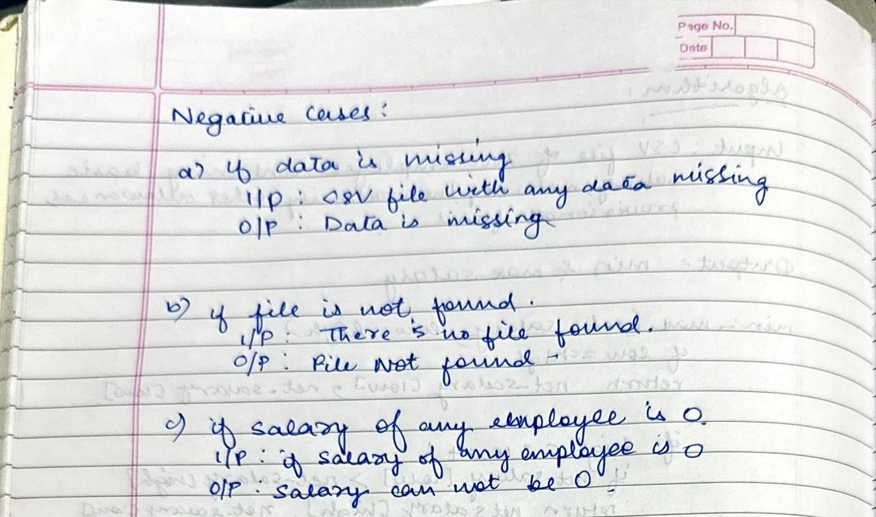

**Formulas:**

Gross Salary=Basic Salary + Allowances+ Bonuses

Net Salary: Gross Salary - Deductions

**Time Complexity:**

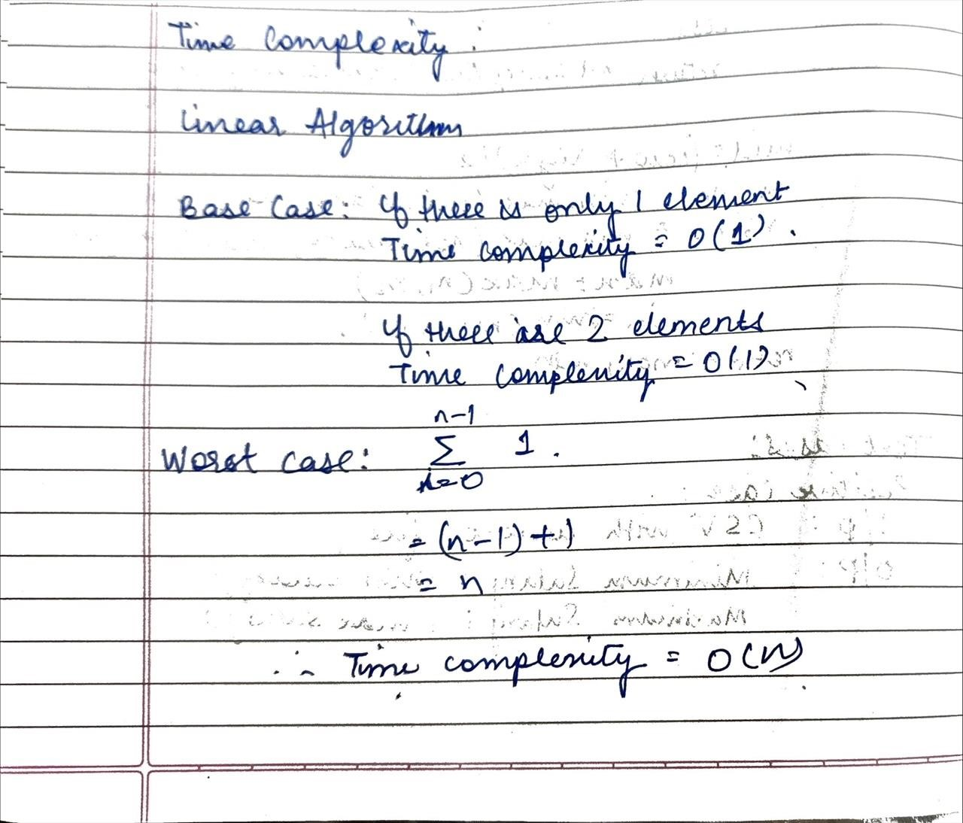

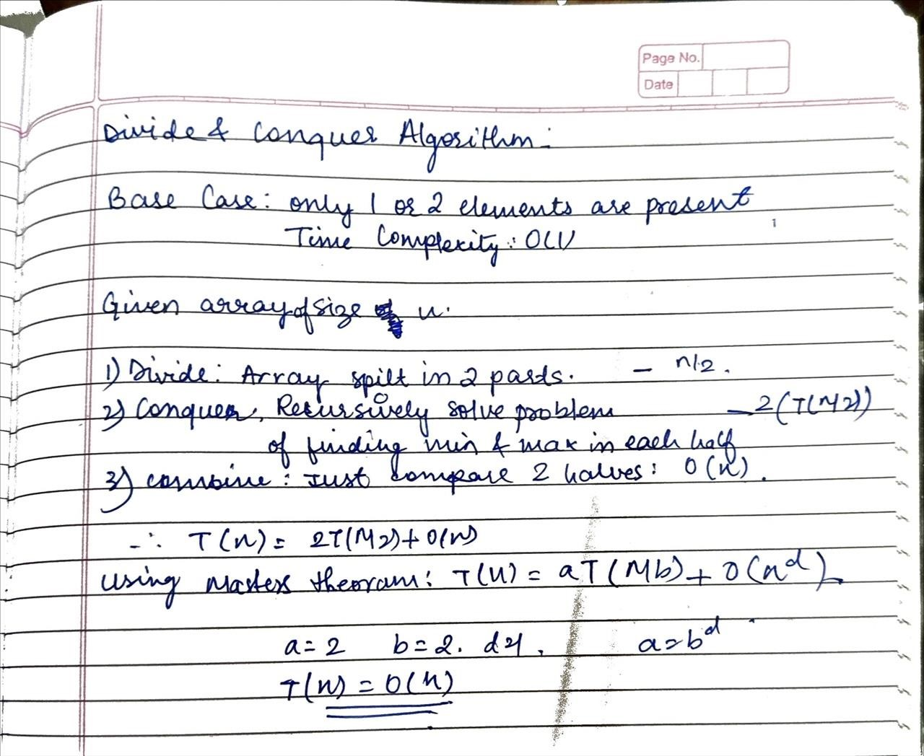

**Code:**

|  |
| --- |
| import csv  class data_analysis:  def gross_sal(s, basic, metro, other):  s.HRA = basic * 0.05 if metro else basic * 0.04  s.PF = basic * 0.12  s.gross = basic + s.HRA + other - s.PF return s.gross  def net_sal(s, gross, inc_tax):  s.net = gross - inc_tax return s.net  def extract_minmax(s, arr):  s.min_val = float('inf')  s.max_val = float('-inf') for _, net in arr: if net < s.min_val: |

|  |
| --- |
| s.min_val = net if net > s.max_val:  s.max_val = net return s.min_val, s.max_val  def check_missing_data(s, file): missing_data_found = False  for row in file: if any(cell == '' or cell is None for cell in row):  missing_data_found = True print(row) break  return missing_data_found  def data_is_zero(s, file):  for row in file : if int(row[1]) == 0:  print("Salary cannot be zero") break  def data_is_negative(s, file): for row in file : if int(row[1]) < 0:  print("Salary cannot be negative") break  def data_is_ne_min(s, file):  non_negative = [ int(i[1]) for i in file if int(i[1]) > 0 ] if non_negative :  min_non = min(non_negative) return min_non def main():  obj1 = data_analysis()  input_file = 'employee_data.csv' output_file = 'datatest.csv'    net_sort = []  try: with open(input_file, 'r') as fin:  reader = csv.reader(fin) rows = list(reader) # Check for missing data if obj1.check_missing_data(rows): |
| print("Missing data found in the CSV file.") return obj1.data_is_zero(rows) obj1.data_is_negative(rows) for line in rows: empID = line[0] basic = float(line[1]) metro = line[2] == 'YES' other = float(line[3]) inc_tax = float(line[4])  gross = obj1.gross_sal(basic, metro, other) net = obj1.net_sal(gross, inc_tax)  net_sort.append((empID, net))  except FileNotFoundError:  print(f"The file '{input_file}' does not exist.")  with open(output_file, 'w', newline='') as fout:  writer = csv.writer(fout) for empID, net in net_sort:  writer.writerow([empID, obj1.gross_sal(basic, metro, other), net])  min_net, max_net = obj1.extract_minmax(net_sort)  if min_net < 0 :  print("Minimum salary from remaining dataset is :") m = obj1.data_is_ne_min(rows) print(f"Minimum Net Salary: {m}") else :  print(f"Minimum Net Salary: {min_net}") print(f"Maximum Net Salary: {max_net}")  if __name__ == "__main__":  main() |

**Output:**

**Positive:**

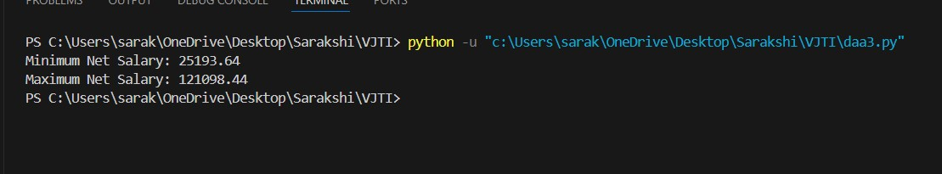

**Negative:**

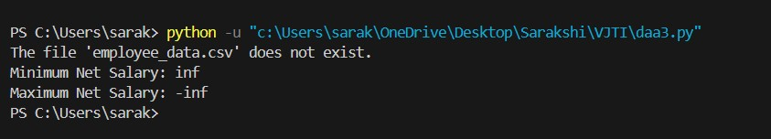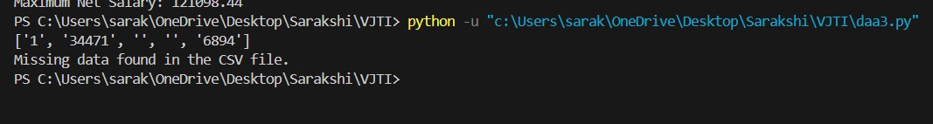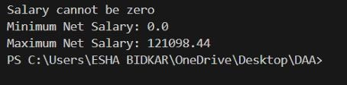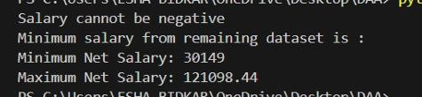

**Conclusion:** In this experiment, we have seen that the divide and conquer algorithm has time complexity of O(n). In both linear and divide and conquer algorithm, divide and conquer algorithm is more preferable. Divide and conquer method is easy to handle in case of large dataset as it divides the problem into smaller subproblems.